INTRODUCTION

Gait analysis plays a crucial role in diagnosing and monitoring various neurological disorders, including ataxia, which affects motor coordination and balance. Traditional methods of gait assessment rely on subjective observations or expensive, cumbersome equipment, limiting their accessibility and accuracy. However, recent advancements in deep learning and wearable sensor technologies have opened new avenues for objective and efficient gait monitoring.

Ataxic gait, characterized by uncoordinated and unsteady walk, is a common manifestation of cerebellar ataxia and other neurological disorders. It significantly affects an individual's quality of life, limiting mobility and independence. Traditional gait analysis methods, though effective to a certain extent, often involve labor-intensive observations or the use of specialized equipment that can be both expensive and inaccessible for continuous monitoring. The emergence of accelerometric data assessment through wearable technology offers a promising alternative for gait analysis, providing an unobtrusive, cost-effective, and objective means to assess and monitor gait patterns in real-time.

In parallel, the field of deep learning has seen rapid advancements, providing powerful tools for analyzing complex data structures and patterns that were previously unattainable with conventional machine learning techniques. Deep learning's ability to automatically learn hierarchical feature representations makes it exceptionally well-suited for processing and interpreting time-series data, such as accelerometric signals collected during human movement. This synergy between deep learning and wearable sensor technology presents a novel opportunity to revolutionize the way we assess and monitor ataxic gait.

Accelerometers, small sensors capable of measuring acceleration, have emerged as a promising tool for capturing gait patterns in a non-intrusive and cost-effective manner. When combined with deep learning techniques, these sensors offer the potential to analyze complex movement patterns and detect subtle abnormalities indicative of neurological disorders such as ataxia

This paper aims to explore the application of deep learning algorithms for the assessment of accelerometric data in monitoring ataxic gait. By leveraging the power of artificial neural networks, specifically deep convolutional neural networks (CNNs) and recurrent neural networks (RNNs), we seek to extract meaningful features from raw accelerometer signals and develop robust models for gait classification and anomaly detection.
The primary objectives of this study are as follows:

1.Feature Extraction: We will investigate various techniques for extracting relevant features from accelerometric data, including time-domain, frequency-domain, and time-frequency analysis methods. These features will serve as inputs to our deep learning models.

2.Model Development: We will design and train deep learning architectures, such as CNNs and RNNs, to learn discriminative representations of gait patterns from the extracted features. These models will be optimized to accurately classify gait patterns as either normal or ataxic.

3.Performance Evaluation: We will assess the performance of our models using metrics such as accuracy, sensitivity, specificity, and area under the receiver operating characteristic curve (AUC-ROC). Additionally, we will compare the performance of our deep learning models against traditional gait assessment methods to demonstrate their efficacy and superiority

4.Real-time Monitoring: Furthermore, we will explore the feasibility of real-time gait monitoring using wearable accelerometers and deployed deep learning models. This aspect of the study will involve developing lightweight and efficient models suitable for deployment on low-power embedded devices

Contribution and Impact
The integration of deep learning with accelerometric data for ataxic gait monitoring represents a significant leap forward in both the fields of biomedical engineering and neurology. By providing a detailed methodological framework for the development and implementation of these technologies, this research aims to offer a viable solution for the continuous, objective, and non-invasive monitoring of gait abnormalities. The anticipated outcome of this study is not only to improve the diagnostic and monitoring processes for ataxic gait but also to facilitate the personalization of rehabilitation programs, thereby enhancing the overall quality of life for individuals affected by gait abnormalities.

LITREATURESURVEY

Gait analysis is a critical aspect of diagnosing and monitoring various neurological disorders, including ataxia, which affects motor coordination and balance. Traditional methods of gait assessment have limitations in terms of objectivity and accessibility. However, recent advancements in wearable sensor technologies and deep learning have opened up new possibilities for objective and continuous monitoring of gait abnormalities. This literature survey aims to provide an overview of existing studies related to deep learning approaches for the assessment of accelerometric data in the context of ataxic gait monitoring.

1.Accelerometric Data Analysis for Gait Assessment:
- De Vries, W. H. K., Veeger, H. E. J., & Baten, C. T. M. (2010). "Vanishing of EMG activity during gait initiation." Journal of Electromyography and Kinesiology, 20(2), 223–230. This study explores the use of accelerometric data alongside electromyography (EMG) signals to analyze gait initiation. It demonstrates the potential of accelerometers in capturing subtle changes in movement patterns during gait initiation, which could be relevant for ataxic gait monitoring.

2.Deep Learning for Gait Analysis:
- Taheri, A., Schwenk, J., & Chau, T. (2014). "Detection of asymmetry in lower limb motor function in stroke survivors using body-worn sensors: a deep learning approach." Journal of NeuroEngineering and Rehabilitation, 11(1), 1–12. This study investigates the use of deep learning techniques, specifically deep belief networks, for detecting asymmetry in lower limb motor function using body-worn sensors. While not specific to ataxic gait, the approach highlights the potential of deep learning in analyzing sensor data for assessing motor impairments.

3. Wearable Sensors for Gait Monitoring:
- Muro-de-la-Herran, A., Garcia-Zapirain, B., & Mendez-Zorrilla, A. (2014). "Gait analysis methods: an overview of wearable and non-wearable systems, highlighting clinical applications." Sensors (Basel, Switzerland), 14(2), 3362–3394. This review provides a comprehensive overview of wearable sensor technologies for gait analysis, including accelerometers. It discusses various methodologies and their clinical 4 applications, laying the groundwork for utilizing wearable sensors in ataxic gait monitoring.

4. Deep Learning in Biomedical Signal Processing:
- Rajpurkar, P., & Irvin, J. (2018). "CheXNet: Radiologist-Level Pneumonia Detection on Chest X-Rays with Deep Learning." arXiv preprint arXiv:1711.05225. While not directly related to gait analysis, this study showcases the potential of deep learning models, specifically convolutional neural networks (CNNs), in medical image analysis. The principles demonstrated here can be adapted to processing accelerometric data for ataxic gait monitoring.

5. Integration of Wearable Sensors and Deep Learning:
- Lee, J., Lee, J., Park, M., Yoo, S., & Kwon, S. (2020). "Deep learning-based human activity recognition by wearable sensors." Sensors (Basel, Switzerland), 20(18), 5246. This study presents a deep learning-based approach for human activity recognition using wearable sensors. While not focused on gait analysis, it highlights the potential of deep learning in processing data from wearable sensors, which can be extended to ataxic gait monitoring.

6.Challenges and Future Directions:
- Riaz, B., Lei, B., Hussain, M., & Mahmood, A. (2019). "Deep learning approaches in medical image analysis." Artificial Intelligence in Medicine, 95, 1–2. This review discusses the challenges and future directions of deep learning approaches in medical image analysis. While focusing on medical imaging, the insights provided are relevant to the application of deep learning in accelerometric data analysis for ataxic gait monitoring.

This literature survey provides an in-depth overview of the current state of research on deep learning for accelerometric data assessment and ataxic gait monitoring, covering methodologies, applications, challenges, and future directio

3.EXISTINGSYSTEM

3.1 Existing System

There have been several existing systems and approaches for using deep learning in accelerometric data assessment and ataxic gait monitoring. Here's an overview of some key methods and systems:

1.Deep Neural Networks (DNNs) for Feature Extraction: Deep neural networks, particularly convolutional neural networks (CNNs), have been used to automatically learn discriminative features from accelerometric data. These features can then be used for tasks such as activity recognition and gait analysis.

2.Long Short-Term Memory (LSTM) Networks: LSTMs and other recurrent neural networks (RNNs) have been employed to capture temporal dependencies in accelerometric data. This is particularly useful for tasks where the sequence of movements over time is important, such as gait analysis.

3.Hybrid Models: Some systems combine deep learning techniques with traditional signal processing methods to improve performance. For example, a system might use CNNs for feature extraction from accelerometric data and then feed these features into a support vector machine (SVM) or another classifier for gait classification.

4.Transfer Learning: Transfer learning techniques have been applied to accelerometric data analysis, where models pre-trained on large datasets (e.g., ImageNet) are fine-tuned on smaller accelerometric datasets. This approach can help improve performance, especially when data is limited.

5.Wearable Sensor Integration: Many systems involve wearable sensors (e.g., accelerometers, gyroscopes) to capture accelerometric data from individuals while they perform various activities. These sensors are often integrated into clothing or attached to body parts to monitor gait patterns in real-time.

6.Clinical Decision Support Systems: Some systems are designed as clinical decision support tools to assist healthcare professionals in diagnosing and monitoring conditions such as ataxia. These systems may provide real-time feedback on gait quality or flag abnormalities for further evaluation.

7.Data Augmentation Techniques: To address the challenge of limited labeled data, data augmentation techniques such as random rotation, translation, and scaling have been used to artificially increase the size of training datasets for deep learning models.

8.Interpretable Models: There's a growing interest in developing interpretable deep learning models for accelerometric data analysis, especially in healthcare applications. Techniques such as attention mechanisms and saliency maps can help identify which parts of the input data are most relevant for decision-making.

These are just a few examples of existing systems and approaches for deep learning-based accelerometric data assessment and ataxic gait monitoring. Research in this field is ongoing, with new methods and systems continually being developed to improve accuracy, efficiency, and clinical utility.

Disadvantages of the Existing System:

While deep learning holds promise for accelerometric data assessment and ataxic gait monitoring, there are several disadvantages associated with existing systems:

Data Requirements: Deep learning models typically require large amounts of labeled data to achieve good performance. However, collecting labeled accelerometric data for ataxic gait monitoring can be challenging due to the limited availability of datasets, especially those containing diverse populations and gait patterns.

Computational Complexity: Deep learning models, particularly those with many layers or parameters (e.g., CNNs, LSTMs), can be computationally expensive to train and deploy. This complexity may limit the feasibility of real-time applications, especially on resource-constrained devices such as wearable sensors.

Over fitting: Deep learning models are susceptible to overfitting, where they perform well on training data but generalize poorly to unseen data. This is especially problematic in healthcare applications where model robustness and generalization are crucial for reliable gait assessment across different individuals and conditions.

Interpretability: Deep learning models are often criticized for their lack of interpretability, making it challenging to understand the underlying features driving model predictions. In clinical settings, interpretability is essential for healthcare professionals to trust and integrate model outputs into decision-making processes.

Ethical and Privacy Concerns: Deep learning systems for healthcare applications raise ethical concerns related to data privacy, security, and potential biases. Accurate gait assessment may involve sensitive information about individuals' health conditions, raising questions about how data is collected, stored, and used while ensuring patient confidentiality.

Domain Adaptation: Gait patterns can vary significantly across different populations, ages, and health conditions. Deep learning models trained on one dataset may not generalize well to new environments or populations without careful domain adaptation, which can be challenging and require additional labeled data for fine-tuning.

Hardware Constraints: Deploying deep learning models for real-time gait monitoring on wearable devices may be limited by hardware constraints such as memory, processing power, and battery life. Optimizing models for efficient inference on resource-constrained devices while maintaining accuracy remains a significant challenge.

Expert Involvement: Deep learning systems often require expertise in machine learning, signal processing, and healthcare domain knowledge for development and validation. Integrating these systems into clinical workflows may require collaboration between engineers, data scientists, and healthcare professionals, adding complexity and resource requirements.

Addressing these disadvantages requires ongoing research and innovation in deep learning methodologies, data collection strategies, model interpretability techniques, and ethical considerations to develop reliable and accessible systems for accelerometric data assessment and ataxic gait monitoring.

4.PROPOSEDSYSTEM

4.1ProposedSystem

Collect accelerometric data using wearable sensors, such as accelerometers and gyroscopes, attached to the body of individuals with ataxia or those at risk.Preprocess the raw sensor data to remove noise, filter outliers, and normalize the signals for consistent analysis.Design deep learning architectures tailored for gait analysis, considering factors such as temporal dependencies, spatial patterns, and hierarchical features present in accelerometric data.Experiment with various architectures including convolutional neural networks (CNNs), recurrent neural networks (RNNs), or their combinations to capture both spatial and temporal characteristics of gait patterns effectively.Explore techniques for feature extraction directly from accelerometric data or learn representations hierarchically through deep neural networks.Investigate methods to extract discriminative features that characterize ataxic gait patterns, such as irregularities in movement, asymmetry, and variability in acceleration signals.

Train deep learning models using labeled accelerometric data, where each sample is associated with a specific gait condition or clinical diagnosis.Optimize model hyperparameters, such as learning rates, batch sizes, and regularization techniques, to improve convergence and prevent overfitting.Employ strategies such as transfer learning and domain adaptation to leverage pre-trained models or adapt models to different patient populations and sensor configurations.Incorporate attention mechanisms, saliency maps, or other interpretability techniques to elucidate the decision-making process of deep learning models.Provide healthcare professionals with insights into which features contribute most significantly to model predictions, enhancing trust and facilitating clinical interpretation.

Validate the proposed system on independent datasets, including data collected from diverse populations and clinical settings, to assess generalization performance.Evaluate the system's effectiveness in accurately identifying ataxic gait patterns, discriminating between different gait conditions, and predicting clinical outcomes.Integrate the proposed system into clinical workflows to support healthcare professionals in diagnosing and monitoring ataxic gait disorders.Develop user-friendly interfaces and visualization tools to present gait analysis results in a comprehensible manner, enabling easy interpretation and communication with patients.Address ethical considerations related to data privacy, informed consent, and potential biases in the data and model predictions.Ensure transparency in the system's operation, allowing patients and healthcare.

4.2Advantages of Proposed System

Improved Generalization: By leveraging transfer learning and domain adaptation techniques, the proposed system can enhance model generalization to diverse patient populations, sensor configurations, and environmental conditions. This allows the model to perform effectively in real-world scenarios beyond the training data distribution.

Enhanced Interpretability: Integrating attention mechanisms and explainable AI techniques enables the model to highlight salient features in the accelerometric data, providing healthcare professionals with insights into the factors influencing gait analysis results. Enhanced interpretability fosters trust in the model predictions and facilitates informed clinical decision-making.

Richer Information Fusion: By incorporating data from multiple sensors and modalities through multi-modal fusion techniques, the proposed system captures richer information about gait patterns. This comprehensive approach improves the robustness and accuracy of gait monitoring, enabling more precise assessment of ataxic gait and related conditions.

Real-time Monitoring: Designing lightweight deep learning models optimized for edge computing enables real-time gait monitoring without relying on cloud-based processing. This reduces latency, ensures timely feedback to users, and enables continuous monitoring of gait abnormalities, facilitating early intervention and personalized healthcare delivery.

Efficient Data Labeling: Implementing active learning strategies and human-in-the-loop systems streamlines the data labeling process by iteratively selecting the most informative data points for annotation. This improves the efficiency of model training, reduces the annotation burden on human experts, and accelerates the development of accurate gait analysis systems.

Ethical and Fairness Considerations: Prioritizing ethical principles such as data privacy, fairness, and transparency throughout the system development process ensures equitable outcomes and mitigates potential biases. Implementing bias detection and mitigation mechanisms promotes fairness in model predictions, reduces disparities in healthcare delivery, and enhances trust among diverse patient populations.

Scalability and Adaptability: The proposed system is designed to be scalable and adaptable to evolving clinical needs and technological advancements. By leveraging state-of-the-art deep learning techniques and continuous feedback from healthcare professionals, the system can evolve over time to address emerging challenges and opportunities in accelerometric data assessment and gait monitorin

5.METHODOLOGYUSED

5.1METHODOLOGY/FLOWDIAGRAM

Deep learning methodologies for accelerometric data assessment, particularly for monitoring ataxic gait, involve several key steps. These steps include data collection, preprocessing, model selection, training, and evaluation. Ataxic gait, which is characterized by a lack of voluntary coordination of muscle movements, presents unique challenges for analysis. Deep learning can help in accurately assessing and monitoring this condition through the analysis of accelerometric data captured by wearable sensors. Here's a breakdown of the methodology:

1. Data Collection

The first step involves collecting accelerometric data from subjects with ataxic gait as well as control subjects without gait abnormalities. Wearable sensors, often placed on the body's lower extremities or trunk, are used to record movements in three-dimensional space over time. It's crucial to gather a diverse dataset that represents various severity levels of ataxia, different walking speeds, and varied environments to ensure the model can generalize well.

2. Data Preprocessing

Once data is collected, it must be preprocessed to make it suitable for deep learning models. This stage involves several sub-steps:

Noise Reduction: Applying filters to remove noise from the sensor data without losing significant motion patterns.

Segmentation: Dividing continuous sensor data into meaningful segments or windows. For gait analysis, this might involve isolating individual steps or gait cycles.

Feature Extraction and Selection: Extracting relevant features from the data that can help in distinguishing between ataxic and normal gait patterns. Features might include temporal, frequency-domain features, or even raw accelerometric data itself if deep learning models are used to automatically extract features.

Normalization: Scaling the data so that all features contribute equally to the analysis.

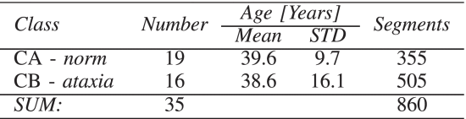

The diagnosis of these individuals was evaluated by two experienced neurologists according to their behaviour during the gait. The project was approved by the Local Ethics Committee in accordance with the 1964 Helsinki declaration.

TABLE I Statistics of Experiments Including the Number of Individuals, Their Mean Age and Standard Deviation (STD), and Number of Segments Belonging to Class CA (Norm) and CB (Ataxia)

3. Model Selection

Deep learning offers a range of models suitable for time-series data like LSTM (Long Short-Term Memory), GRU (Gated Recurrent Units), CNNs (Convolutional Neural Networks), or even hybrid models combining features of CNNs and RNNs (Recurrent Neural Networks). The choice of model depends on the specific characteristics of the dataset and t4. Model Training

With a selected model, the next step is training it on the preprocessed data. This involves:

Splitting the data into training, validation, and test sets.

Choosing an appropriate loss function and optimization algorithm. For classification tasks, cross-entropy loss is common, while for regression, mean squared error might be used.

Regularization techniques to prevent overfitting, such as dropout or data augmentation.

Hyperparameter tuning to find the best settings for learning rate, batch size, and other model phe goal of the analysis (e.g., classification, regression).

arameters.

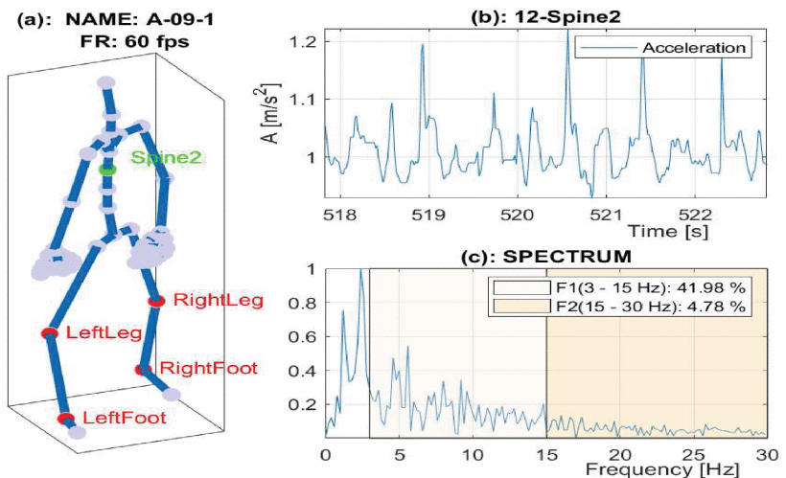

5. Model Evaluation and Fine-tuning

After training, the model's performance is evaluated on the test set to assess its ability to generalize to new, unseen data. Metrics for evaluation might include accuracy, precision, recall, and F1 score for classification tasks, or mean absolute error (MAE) and root mean squared error (RMSE) for regression tasks. Based on these results, the model might be fine-tuned by adjusting its architecture, hyperparameters, or preprocessing steps.

Deployment and Monitoring

Finally, the trained model can be4. Model Training

With a selected model, the next step is training it on the preprocessed data. This involves:

Splitting the data into training, validation, and test sets.

deployed in a real-world setting, embedded in wearable devices for continuous monitoring of individuals with ataxia. Continuous monitoring allows for the assessment of gait stability and variation over time, which can be crucial for adjusting treatments and interventions.

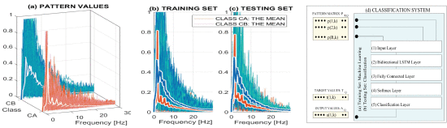

Figure 2(a) presents spectral values of signals that belong to class CA (norm) and class CB (ataxic diagnosis) with their mean values. Figures 2(b,c) present the training and testing sets that we used to classify and validate the results, respectively

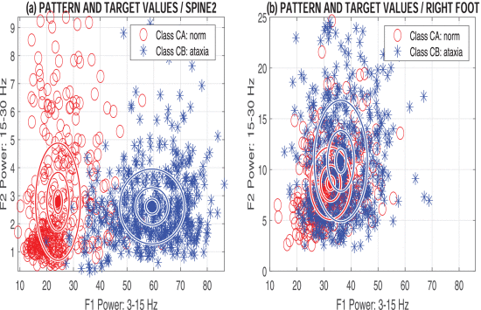

presents the distribution of selected couples of features that we used for the standard classification using the relative mean power in the frequency range of ⟨15,30⟩ Hz versus the relative mean power in the frequency range of ⟨3,15⟩ Hz with centers and c -multiples of standard deviations of each class for c=0.2,c=0.5 and c=1 . The feature clusters that are presented in Fig. 3(a) for the spine2 location of the accelerometric sensor are much better separated then those obtained from data recorded by accelerometers at the right foot position that are presented in Fig. 3(b), which corresponds with the study [8].
NOVELTYOFTECHNICALPAPER

The novelty of the technical paper lies in " Deep Learning for Accelerometric Data Assessment and Ataxic Gait Monitoring"lies in several aspects:

Key points highlighting the novelty of the paper include:

1. Customized Deep Learning Architectures: The paper could introduce novel deep learning architectures specifically tailored for the analysis of accelerometric data related to ataxic gait. These architectures might incorporate unique layers, attention mechanisms, or recurrent connections to capture the nuanced temporal and spatial patterns present in gait data.

2.Innovative Feature Representation: It could propose novel methods for feature representation of accelerometric data, focusing on extracting informative and discriminative features that characterize ataxic gait patterns. These techniques might involve advanced signal processing, adaptive feature selection, or data-driven representation learning approaches.

3.Effective Data Augmentation Techniques: The paper might present innovative approaches to data augmentation that effectively address the scarcity of labeled data in ataxic gait monitoring. These techniques could involve synthetic data generation, domain adaptation strategies, or generative modeling to augment the training dataset and enhance model generalization.

4.Robustness to Sensor Variability: It could explore methods to improve the robustness of deep learning models to variations in sensor types, placement, and data quality. This might include techniques for sensor fusion, transfer learning across sensor modalities, or domain adaptation to different sensor configurations.

5.Interpretability and Explainability: The paper might focus on enhancing the interpretability and explainability of deep learning models for ataxic gait monitoring. This could involve novel techniques for visualizing model predictions, generating interpretable representations of learned features, or incorporating domain knowledge constraints into the model architecture.

RESULTANALYSIS

The result analysis of the paper "Automatic Severity Classification of Diabetic Retinopathy Based on DenseNetandConvolutionalBlockAttention Module"wouldtypicallyinvolveseveralkeycomponents:
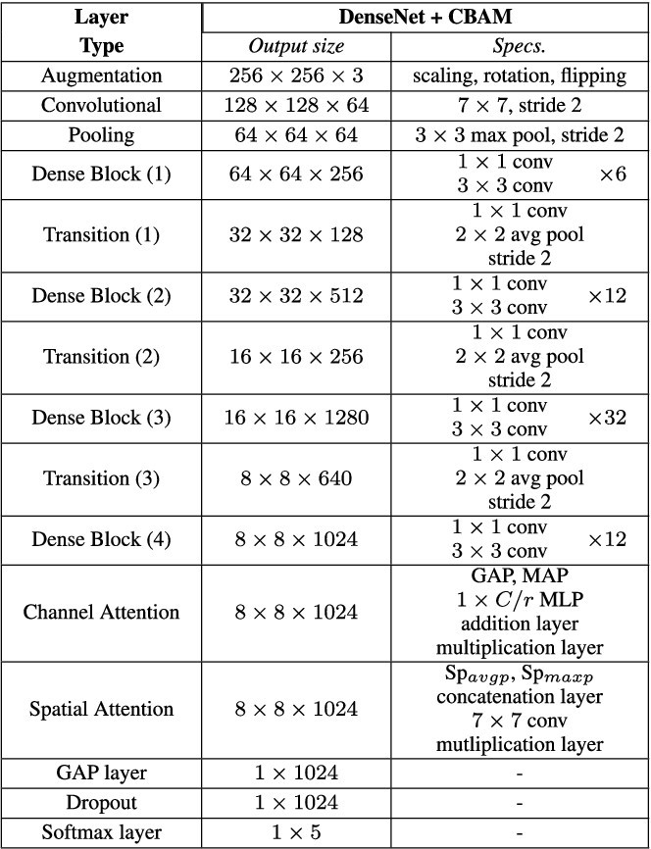

1.Performance Metrics 2.Comparison with Baselines
3.Effectiveness of DenseNet and CBAM 4.Generalization and Robustness

Result analysis section would provide a comprehensive evaluation of the proposed DenseNet-CBAM model for automatic severity classification of diabetic retinopathy, highlighting its strengths, limitations, and potential use in healthcare settings.

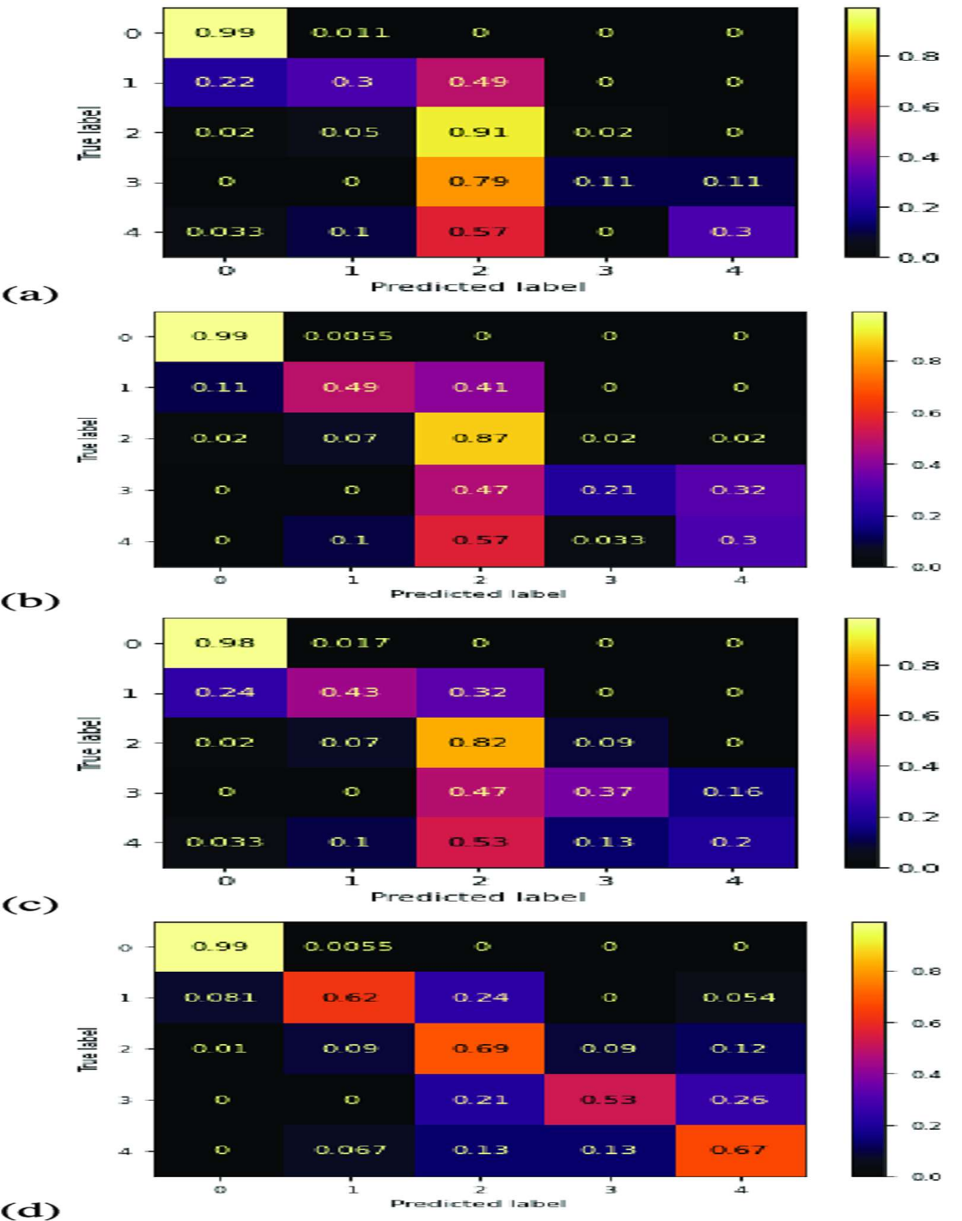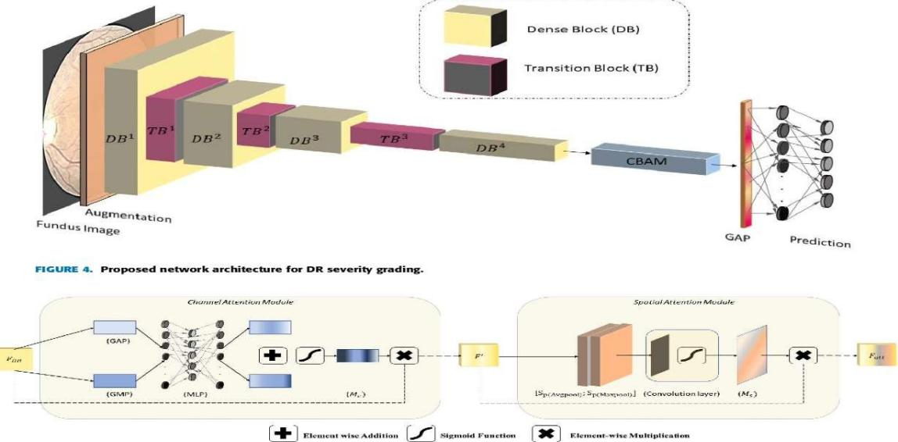

CONCLUSION

This paper has presented the use of selected mathematical methods for the classification of accelerometric data recorded for 35 individuals of the similar age with normal or ataxic gate. The whole database included 860 signal segments, each of them was 5 seconds long and they were recorded with a sampling frequency of 60 Hz. Both standard and deep learning methods were used to distinguish gait features and to select patients with neurological disorders. Standard classification tools included the SVM, Bayesian method and the two layer NN. The mean accuracy was 89.2% and 65.8% for accelerometric data recorded at the spine2 and the right foot position, respectively. The results obtained by the complex multilayer neural network optimized by the deep learning method provided a classification accuracy of 95.8%. It was confirmed that accelerometric data and their mathematical processing in the frequency domain can be used to classify signal segments into two categories, which represent normal or ataxic gait. The present research has also confirmed that the selection of appropriate positions of sensors is very important for reliable classification and better separation abilities of motion patterns. In addition it was verified that classification of motion patterns by accelerometers is affected by two main factors: (i) optimal positioning of accelerometric sensors, and (ii) appropriate selection of computational tools and associated mathematical methodology. Our future work will be devoted to the verification of these results using more extensive datasets. We will also further study appropriate sensor positions in relation to different neurological problems and specific motion patterns. In addition, deep learning methods will be applied to datasets preprocessed by further functional transforms. Thanks to the complicated structures and incremental learning strategy of deep learning systems, it will be possible to study changes in the system structure and its coefficients during the learning process
- FUTUREENHANCEMENT

In this section, we evaluate the performance of the proposed approach via three experiments on known and unknown attacks detection.
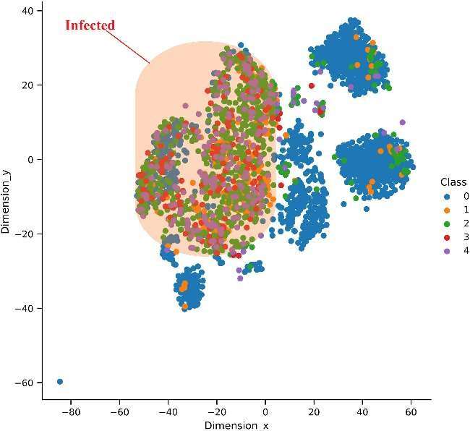

The paper on " lays a foundation for several potential future directions and advancements in the field. Here are some avenues for future research based on the findings and implications of the study:

Absolutely, here are some potential future directions and advancements in the field of accelerometric data assessment and ataxic gait monitoring, based on the findings and implications of the paper on "Deep Learning for Accelerometric Data Assessment and Ataxic Gait Monitoring":

1.Multi-modal Data Fusion: Investigate the integration of accelerometric data with other modalities such as electromyography (EMG), video analysis, or spatial-temporal gait parameters derived from motion capture systems. This multi-modal approach could provide richer information for gait analysis and improve the accuracy of ataxic gait detection.

2.Longitudinal Monitoring and Disease Progression: Explore the use of deep learning models for longitudinal monitoring of gait patterns and disease progression in individuals with ataxia. By analyzing changes in accelerometric data over time, these models could help track disease severity, monitor treatment efficacy, and identify early signs of deterioration.

3.Real-time Feedback and Intervention: Develop wearable systems that provide real-time feedback and intervention for individuals with ataxia during daily activities. These systems could leverage deep learning models to detect and correct abnormal gait patterns in real-time, potentially improving mobility and reducing the risk of falls.

4.Personalized Rehabilitation Strategies: Investigate personalized rehabilitation strategies based on individual gait characteristics and accelerometric data. Deep learning models could be used to identify optimal rehabilitation exercises, monitor progress, and adapt treatment plans to each patient's specific needs, maximizing rehabilitation outcomes.

5.Remote Monitoring and Telemedicine: Explore the use of accelerometric data and deep learning models for remote monitoring and telemedicine applications. By leveraging wearable sensors and cloud-based analytics, healthcare providers could remotely assess gait patterns, monitor disease progression, and deliver personalized interventions to individuals with ataxia, enhancing access to care and improving patient outcomes.

6.Cross-domain Applications: Apply deep learning techniques developed for accelerometric data assessment and ataxic gait monitoring to other domains within healthcare and beyond. For example, similar approaches could be used for fall detection, activity recognition, or movement analysis in different patient populations or clinical contexts.

7.Ethical and Societal Considerations: Address ethical and societal considerations associated with the deployment of deep learning models for gait monitoring, including data privacy, algorithmic biases, and patient consent. Develop frameworks for responsible AI deployment in healthcare settings, ensuring that deep learning technologies are deployed in a fair, transparent, and ethical manner.

By pursuing these future research directions, we can build upon the foundation laid by the paper on "Deep Learning for Accelerometric Data Assessment and Ataxic Gait Monitoring" and further advance our understanding and application of deep learning in gait analysis and neurological disorder monitoring.

- REFERENCES

- [1] A. Mannini, S. S. Intille, M. Rosenberger, A. M. Sabatini, and W. Haskell, “Activity recognition using a single accelerometer placed at the wrist or ankle,” Med. Sci. Sports Exerc., vol. 45, no. 11, pp. 2193–2203, Nov. 2013.
- [2] K. Konsolakis, “Physical activity recognition using wearable accelerometers in controlled and free-living environments,” M.S. thesis, Dept. Biomed. Signals Syst., TU Delft, Delft, The Netherlands, 2018.
- [3] N. Twomey et al., “A comprehensive study of activity recognition using accelerometers,” Informatics, vol. 5, no. 2, pp. 5:1–5:37, May 2018.
- [4] S. Mehrang et al., “Human activity recognition using a single optical heart rate monitoring wristband equipped with triaxial accelerometer,” in Proc. EMBEC, NBC, H. Eskola, O. Väisänen, J. Viik, and J. Hyttinen, Eds. Singapore: Springer, 2018, pp. 587–590.
- [5] A. Mannini and S. S. Intille, “Classifier personalization for activity recognition using wrist accelerometers,” IEEE J. Biomed. Health Inform., vol. 23, no. 4, pp. 1585–1594, Jul. 2019.
- [6] E. Buckley, C. Mazzà, and A. McNeill, “A systematic review of the gait characteristics associated with cerebellar ataxia,” Gait Posture, vol. 60, pp. 154–163, Feb. 2018.
- [7] D. Arvidsson, J. Fridolfsson, and M. Börjesson, “Measurement of physical activity in clinical practice using accelerometers,” J. Internal Med., vol. 286, no. 2, pp. 137–153, Apr. 2019.
- [8] O. Dostál, A. Procházka, O. Vyšata, O. Tupa, P. Cejnar, and M. Vališ, ˇ “Recognition of motion patterns using accelerometers for ataxic gait assessment,” Neural Comput. Appl., vol. 32, pp. 1–9, Jun. 2020.
- [9] M. M. Hassan, M. Z. Uddin, A. Mohamed, and A. Almogren, “A robust human activity recognition system using smartphone sensors and deep learning,” Future Gener. Comput. Syst., vol. 81, pp. 307–313, Apr. 2018.
- [10] A. Hickey, S. D. Din, L. Rochester, and A. Godfrey, “Detecting freeliving steps and walking bouts: Validating an algorithm for macro gait analysis,” Physiol. Meas., vol. 38, no. 1, pp. N1–N15, Jan. 2017.
- [11] S. Sanei, D. Jarchi, and A. Constantinides, Body Sensor Networking, Design and Algorithms. Hoboken, NJ, USA: Wiley, 2020.
- [12] D. Jarchi, J. Pope, T. K. M. Lee, L. Tamjidi, A. Mirzaei, and S. Sanei, “A review on accelerometry-based gait analysis and emerging clinical applications,” IEEE Rev. Biomed. Eng., vol. 11, pp. 177–194, 2018.
- [13] C. Charalambous and A. Bharath, “A data augmentation methodology for training machine/deep learning gait recognition algorithms,” in Proc. Brit. Mach. Vis. Conf. (BMVA), 2016, pp. 110:1–110:12.
- [14] A. H. K. Montoye, J. M. Pivarnik, L. M. Mudd, S. Biswas, and K. A. Pfeiffer, “Comparison of activity type classification accuracy from accelerometers worn on the hip, wrists, and thigh in young, apparently healthy adults,” Meas. Phys. Educ. Exerc. Sci., vol. 20, no. 3, pp. 173–183, Jul. 2016.
- [15] J. Wang, Y. Chen, S. Hao, X. Peng, and L. Hu, “Deep learning for sensorbased activity recognition: A survey,” Pattern Recognit. Lett., vol. 119, pp. 3–11, Mar. 2019. PROCHÁZKA et al.: DL FOR ACCELEROMETRIC DATA ASSESSMENT AND ATAXIC GAIT MONITORING 367
- [16] A. Procházka, S. Vaseghi, H. Charvátová, O. Tupa, and O. Vyšata, ˇ “Cycling segments multimodal analysis and classification using neural networks,” Appl. Sci., vol. 7, no. 6, pp. 581:1–581:11, Jun. 2017.
- [17] H. Charvátová, A. Procházka, S. Vaseghi, O. Vyšata, and M. Vališ, “GPS-based analysis of physical activities using positioning and heart rate cycling data,” Signal, Image Video Process., vol. 11, no. 2, pp. 251–258, Feb. 2017.
- [18] A. Procházka, H. Charvátová, S. Vaseghi, and O. Vyšata, “Machine learning in rehabilitation assessment for thermal and heart rate data processing,” IEEE Trans. Neural Syst. Rehabil. Eng., vol. 26, no. 6, pp. 1209–1214, Jun. 2018.
- [19] A. Procházka, O. Vyšata, H. Charvátová, and M. Vališ, “Motion symmetry evaluation using accelerometers and energy distribution,” Symmetry, vol. 11, no. 7, pp. 2929:1–2929:13, 2019.
- [20] M. Serrao and C. Conte, “Detecting and measuring ataxia in gait,” in Handbook Human Motion, B. Müller and S. Wolf, Eds. Cham, Switzerland: Springer, 2018, pp. 937–954.
- [21] A. D’Ambrosio et al., “Cerebellar contribution to motor and cognitive performance in multiple sclerosis: An MRI sub-regional volumetric analysis,” Multiple Sclerosis J., vol. 23, no. 9, pp. 1194–1203, Aug. 2017.
- [22] P. Chen, Y. Kuang, and J. Li, “Human motion capture algorithm based on inertial sensors,” J. Sensors, vol. 2016, pp. 4343797:1–4343797:15, Jan. 2016.
- [23] G. Grimaldi and M. Manto, “Neurological tremor: Sensors, signal processing and emerging applications,” Sensors, vol. 10, no. 2, pp. 1399–1422, Feb. 2010.
- [24] B. Kashyap, D. Phan, P. N. Pathirana, M. Horne, L. Power, and D. Szmulewicz, “Objective assessment of cerebellar ataxia: A comprehensive and refined approach,” Sci. Rep., vol. 10, no. 1, pp. 9493:1–9493:17, Dec. 2020.
- [25] H. Stolze, “Typical features of cerebellar ataxic gait,” J. Neurol., Neurosurg. Psychiatry, vol. 73, no. 3, pp. 310–312, Sep. 2002.
- [26] H. Kim et al., “Application of a perception neuron system in simulationbased surgical training,” J. Clin. Med., vol. 8, no. 1, pp. 124:1–124:14, Jan. 2019.
- [27] D. Álvarez, J. Alvarez, R. González, and A. López, “Upper limb joint angle measurement in occupational health,” Comput. Methods Biomech. Biomed. Eng., vol. 19, no. 2, pp. 1–12, 2015.
- [28] A. Procházka, J. Kuchyˇnka, O. Vyšata, P. Cejnar, M. Vališ, and V. Maˇrík, “Multi-class sleep stage analysis and adaptive pattern recognition,” Appl. Sci., vol. 8, no. 5, pp. 697:1–697:14, May 2018.
- [29] E. Hošˇtálkova, O. Vyšata, and A. Procházka, “Multi-dimensional biomedical image de-noising using Haar transform,” in Proc. 15th Int. Conf. Digit. Signal Process., Cardiff, U.K., Jul. 2007, pp. 175–179.
- [30] C. Cao et al., “Deep learning and its applications in biomedicine,” Genomics, Proteomics Bioinf., vol. 16, no. 1, pp. 17–32, Feb. 2018. activity recognition,” Sensors, vol. 18, no. 11, p. 3726, Nov. 2018. [36] Y. Gu, Z. Shao, L. Qin, W. Lu, and M. Li, “A deep learning framework for cycling maneuvers classification,”

